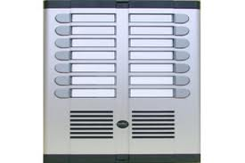
عدد الشقق | اجمالى السعر
3 |  | 1045
4 |  | 1175
6 |  | 1435
8 |  | 1675
10 |  | 1940
12 |  | 2170
14 |  | 2405
16 |  | 2655
18 |  | 2885
20 |  | 3145
22 |  | 3365
24 |  | 3655
26 |  | 3895
30 |  | 4510
32 |  | 4735
36 |  | 5245
40 |  | 5730
44 |  | 6205
48 |  | 6715
52 |  | 7300
54 |  | 7585
58 |  | 8085
64 |  | 8805
70 |  | 9525
72 |  | 9865
76 |  | 10285
80 |  | 10925
88 |  | 11880
92 |  | 12385
96 |  | 12845
104 |  | 13855

